M E M O R A N D U M

To: ACRM

From: Peter Thomas; Allie Hussey and Joe Nahra

Date: August 26, 2019

Re: CY 2020 Home Health Prospective Payment System Proposed Rule

On July 18, 2019, the Centers for Medicare and Medicaid Services (CMS) published a proposed rule to update the Medicare home health prospective payment system (HH PPS) for calendar year (CY) 2020 (Proposed Rule). This memorandum summarizes key updates to the HH PPS and analyzes the potential implications of these updates for providers of home health services and patients receiving home health care under the new payment system. Comments on the Proposed Rule are due by 5:00 p.m. on September 9, 2019.

Change in Unit of Payment

In accordance with the Bipartisan Budget Act of 2018, this Proposed Rule implements the transition in the unit of payment from a sixty-day episode of care to a thirty-day episode of care effective January 1, 2020.

Implementation of the Patient-Driven Groupings Model (PDGM)

The Proposed Rule describes the new case-mix adjustment methodology—the Patient-Driven Groupings Model (PDGM)—that will adjust payments for home health periods starting on January 1, 2020. According to the proposed rule, this model “shift[s] focus from volume of services to a more patient-driven model that relies on patient characteristics.” The PDGM establishes 432 payment groups (also called case-mix groups or Home Health Resource Groups (HHRGs)), which will be used to apply case-mix adjustments to a nationally standardized payment amount for a thirty-day period of care. Unlike current practice, the nationally standardized payment will include payment for non-routine supplies (NRSs). Payment group weights will be updated annually to “reflect the most recent utilization data at the time of annual rulemaking.”

Payment groups will be determined using the following factors:

- Timing – Either “early” (the first thirty-day period of care) or “late” (all subsequent thirty-day periods of care in the sequence). CMS will not consider a thirty-day period to be “early” unless “there is a gap of more than 60 days between the end of one period of care and the start of another.”

- Admission Source – The patient’s healthcare setting—institution or community—in the preceding fourteen-day period.

- Clinical Grouping – Based on the patient’s principal diagnosis reported on the home health claim. The clinical groups include:

  - Musculoskeletal Rehabilitation;
  - Neuro/Stroke Rehabilitation;
  - Wounds – Post-Op Wound Aftercare and Skin/Non-Surgical Wound Care;
  - Behavioral Health Care;
  - Complex Nursing Interventions;
  - Medication Management, Teaching and Assessment – Surgical Aftercare;
  - Medication Management, Teaching and Assessment – Cardiac/Circulatory;
  - Medication Management, Teaching and Assessment – Endocrine;
  - Medication Management, Teaching and Assessment – GI/GU;
  - Medication Management, Teaching and Assessment – Infectious Disease/Neoplasms/Blood-Forming;
  - Medication Management, Teaching and Assessment – Respiratory; and
  - Medication Management, Teaching and Assessment – Other.

- Functional Impairment Level – One of three functional impairment levels (low, medium, or high) based on responses to the following Outcome and Assessment Information Set (OASIS) functional items:

  - Risk for Hospitalizations;
  - Grooming;
  - Current Ability to Dress Upper Body Safely;
  - Current Ability to Dress Lower Body Safely;
  - Bathing;
  - Toilet Transferring;
  - Transferring; and
  - Ambulation and Locomotion.

- Comorbidity Adjustment – Based on the presence of certain secondary diagnoses reported on home health claims. The thirty-day periods of care receive a comorbidity adjustment under the following circumstances:

  - Low Comorbidity Adjustment: “There is a reported secondary diagnosis on the home health-specific comorbidity subgroup list that is associated with higher resource use.” In CY 2020, there are twelve low comorbidity adjustment subgroups.

  - High Comorbidity Adjustment: “There are two or more secondary diagnoses on the home health-specific comorbidity subgroup interaction list that are associated with higher resource use when both are reported together compared to if they were reported separately.” In CY 2020, there are thirty-four high comorbidity adjustment interaction subgroups.

  - No Comorbidity Adjustment: A thirty-day period of care will receive no comorbidity adjustment if there is no secondary diagnosis or if no secondary diagnosis meets the criteria for a low or high comorbidity adjustment.
See Figure 1 below for a visualization of the case-mix variables.

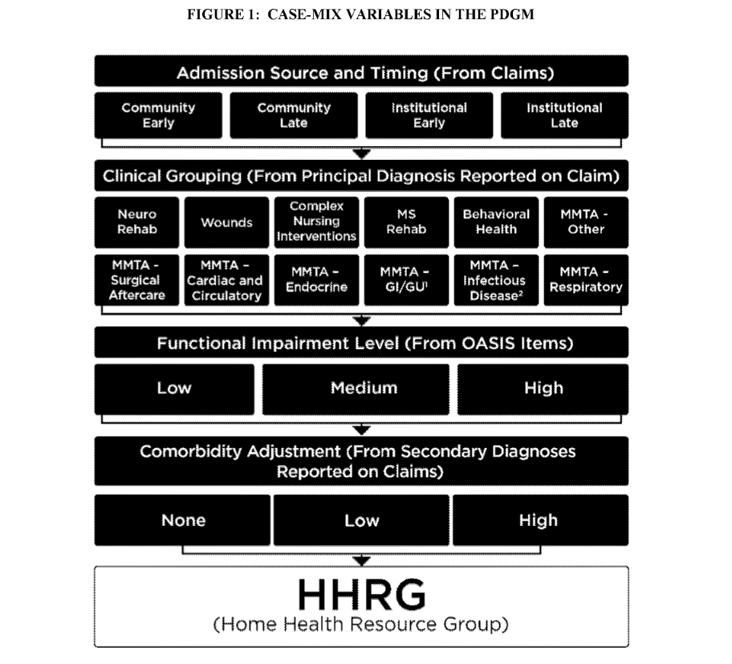

In calculating a thirty-day payment amount in a budget-neutral manner under the PDGM, CMS will make assumptions about changes in provider behavior that could occur as a result of the implementation of the thirty-day unit of payment and the PDGM case-mix adjustment factors. In the CY 2019 HH PPS final rule, CMS set forth three behavioral assumptions: Clinical group coding, comorbidity coding, and low-utilization payment adjustment (LUPA) threshold.

Under the clinical group coding assumption, CMS “proposed to assume that [home health agencies (“HHAs”)] will change their documentation and coding practices and would put the highest paying diagnosis code as the principal diagnosis code in order to have a 30-day period of care be placed into a higher-paying clinical group.” According to CMS, this assumption “is based on decades of past experience under the case-mix system for the HH PPS and other case-mix systems.” CMS specifically cites data concerning the “substantial increase in payments when transitioning from the diagnosis-related groups (DRGs) to the Medicare Severity (MS)-DRGs that were not related to actual changes in patient severity.” In support of its behavioral assumption, CMS points to inpatient hospital claims data and case-mix increases in the first year of the inpatient rehabilitation facility (IRF) PPS, and case-mix growth in the HH PPS.

Under the comorbidity coding assumption, CMS “proposed to assume that by taking into account additional ICD-10-CM diagnosis codes listed on the home health claim (that exceed the 6 allowed on the OASIS), more 30-day periods of care will receive a comorbidity adjustment than periods otherwise would have received if we only used the OASIS diagnosis codes for payment.” CMS provides that “using the home health claim for the comorbidity adjustment as opposed to the OASIS provides more opportunity to report all comorbid conditions that may affect the plan of care.”

Under the LUPA threshold assumption, CMS “proposed to assume that for one-third of LUPAs that are 1 to 2 visits away from the LUPA threshold, HHAs will provide 1 to 2 extra visits to receive a full 30-day payment.” LUPAs occur when there are a low number of visits provided in a thirty-day period of care. In support of this behavioral assumption, CMS references data suggesting that HHAs “changed their practice patterns such that, upon implementation of the HH PPS, more than half of 60-day episodes that would have been LUPAs received the full 60-day episode payment amount.” It also relies on the fact that certain groups have only a two-visit threshold.

In the CY 2019 HH PPS final rule, CMS indicated that applying behavioral assumptions would result in a 6.42 percent reduction in Medicare payments to home health providers in CY 2020. In the Proposed Rule, however, CMS proposes that applying the behavioral assumptions will result in the need to decrease the CY 2020 estimated budget-neutral thirty-day payment amount by 8.01 percent (Clinical group coding assumption = -5.91 percent; comorbidity coding assumption = -0.37 percent; and LUPA threshold assumption = -1.87 percent).

CMS notes that the “data from CYs 2020 through 2026 will be available to determine whether a prospective adjustment (increase or decrease) is needed no earlier than in years 2022 through 2028 rulemaking.” CMS, however, “will analyze data after implementation of the PDGM to determine if there are any notable and consistent trends to warrant whether any changes to the national, standardized 30-day payment rate should be done earlier than CY 2022.”

Split Percentage Payments

Currently, an HHA submits a Request for Anticipated Payment (RAP) at the outset of the initial episode of care. The RAP covers sixty percent of the anticipated full payment. At the end of the episode of care, the HHA submits a claim for the outstanding forty percent. If a patient is receiving “continuous care,” all subsequent episodes are split such that half is paid upfront and half is paid at the end of the period.

CMS proposes phasing out split payments in the coming calendar years. It proposes that, for CY 2020, HHAs that are “certified for participation in Medicare” before January 1, 2019 will only receive twenty percent of final payments upfront on all thirty-day periods of care. HHAs enrolled in Medicare on or after January 1, 2019 will not receive upfront payments in CY 2020 but will still submit “no-pay” RAPs for each thirty-day period of care.

Under the CMS proposal, upfront payments would be abandoned for all HHAs in CY 2021, meaning that all payments would be made upon submission of a final claim. In CY 2021, at the outset of the first period of care, all HHAs would also be required to submit a Notice of Admission (NOA). The NOA must be submitted “within 5 calendar days of the start of care to establish that the beneficiary is under a Medicare home health period of care.” Only one NOA need be submitted unless the patient is discharged and readmitted. In that case, a new NOA would be required within five calendar days of an initial thirty-day period of care.
CMS proposes that the NOA process would be through an Electronic Data Interchange submission. Under the Proposed Rule, an HHA would be subject to a reduction in Medicare payment if it does not timely submit a NOA. CMS proposes that the penalty “would be a 1/30 reduction off of the full 30-day period payment amount for each day until the date the NOA is submitted (that is, from the start of care date through the day before the NOA is submitted…).” CMS would also withhold LUPA payments for the days preceding the submission of an untimely NOA. However, CMS is proposing to waive the consequences of failing to submit a timely-filed NOA if an exceptional circumstance is experienced by the HHA. An exceptional circumstance for such waiver would be, but is not limited to, the following:
- Fires, floods, earthquakes, or similar unusual events that inflict extensive damage to the HHA’s ability to operate.
- A CMS or Medicare contractor systems issue that is beyond the control of the HHA.
- A newly Medicare-certified HHA that is notified of that certification after the Medicare certification date, or which is awaiting its user ID from its Medicare contractor.
- Other situations determined by CMS to not be under the control of the HHA.
Revised LUPA Thresholds

The LUPA threshold for a thirty-day period of care will vary by payment group. The threshold will be the greater of two visits or the tenth percentile value of visits for the payment group. Periods of care that fall below the LUPA threshold will be paid based on the CY 2020 per-visit payment amounts.

CMS will continue to use LUPA add-on payments, for which CMS will “multiply the per-visit payment amount for the first skilled nursing, physical therapy, or speech-language pathology visit in LUPA periods that occur as the only period of care or the initial 30-day period of care in a sequence of adjacent 30-day periods of care by the appropriate add-on factor…”

Rural Add-On Payments

The BBA of 2018 also requires rural add-on payments for episodes or visits ending during CYs 2019 through 2022. These rural add-on payments would differ by “rural county (or equivalent area)” classification: “high utilization;” “low population density;” or “all other.” CMS finalized policies for the rural add-on payments for CY 2019 through CY 2022 in the CY 2019 HH PPS final rule.

Maintenance Therapy by Therapist Assistants

CMS is proposing to permit therapist assistants (in addition to therapists) to perform maintenance therapy under a maintenance program created by a qualified therapist under the Medicare home health benefit, if acting within the therapy scope of practice defined by state licensure laws. Qualified therapists would be responsible for “the initial assessment; plan of care; maintenance program development and modifications; and reassessment every 30 days, in addition to supervising the services provided by the therapist assistant.”

CMS seeks feedback on (1) whether the proposal would require therapists to provide more frequent patient reassessment or maintenance program review when the services are being furnished by a therapist assistant; (2) whether CMS should revise the description of the therapy codes to indicate maintenance services furnished by a physical or occupational therapist assistant (G0151 and G0157) versus a qualified therapist, or remove the therapy code indicating the establishment or delivery of a safe and effective physical therapy maintenance program, by a physical therapist (G0159); (3) the importance of tracking whether a visit is for maintenance or restorative therapy or whether it would be appropriate to only identify whether the service is provided by a qualified therapist or a therapist assistant; and (4) any possible effects on the quality of care that could result by permitting therapist assistants to provide maintenance therapy.

Home Health Plan of Care Regulations

Concerned that current content requirements for the individualized home health plan of care “may be overly prescriptive and may interfere with timely payment for otherwise eligible episodes of care,” CMS is proposing amendments to the home health plan of care content requirements at 42 C.F.R § 409.43(a). The proposed rule states that for home health services to be covered, the plan “must specify the services necessary to meet the patient-specific needs identified in the comprehensive assessment” and “must include the identification of the responsible discipline(s) and the frequency and duration of all visits as well as those items listed in 42 CFR 484.60(a) that establish the need for such services.” CMS states that “violations for missing required items are best addressed through the survey process, rather than through claims denials for otherwise eligible periods of care.”

Home Health Value-Based Purchasing (HHVBP) Model
CMS proposes to publicly report the Total Performance Score (TPS) and the TPS Percentile Ranking from the performance year 5 (CY 2020) Annual TPS and Payment Adjustment Report for each participating HHA that qualified for a payment adjustment for CY 2020.

Home Health Care Quality Reporting Program (HH QRP)
CMS proposes updates to the HH QRP including:
- Removal of the Improvement in Pain Interfering with Activity Measure (NQF #0177) from the HH QRP beginning with CY 2022;
- Adoption of two new quality measures: (1) Transfer of Health Information to Provider-Post-Acute Care; and (2) Transfer of Health Information to Patient-Post-Acute Care;
- Update the specifications for the Discharge to Community-Post-Acute Care HH QRP measure;
- Adoption of various standardized patient assessment data elements; and
- Removal of Question 10, concerning pain communication, from the Home Health Care Consumer Assessment of Healthcare Providers and Systems Surveys.

Implications

As explained above, CMS intends to use behavioral assumptions to decrease base payments for HHAs. CMS notes that behavior assumptions will reduce payment amounts by 8.01 percent as compared to those that would be paid in the absence of behavioral adjustments. This 8.01 percent reduction is even greater than the 6.42 percent reduction that CMS announced in the HH PPS final rule for CY 2019. Although CMS cites some past experience underlying the behavioral assumptions, much of the evidence is conjectural or extrapolated from payment systems other than the HH PPS. As such, it is unclear how accurate, if at all, the behavior assumptions are. Basing payment cuts on behavioral assumptions not grounded in observed evidence deviates from other prospective payment systems and sets a problematic precedent. In fact, CMS declined to make any prediction about providers’ reaction to the proposed skilled nursing facility payment model, noting that it “lacked an appropriate basis to forecast behavioral responses.”

The 8.01 percent decrease in payments is excessively high, totaling approximately $1.3 billion dollars. These payment cuts will present a serious challenge to HHAs, which may have negative consequences for beneficiaries receiving home health services. Significant payment decreases may result in the closure of HHAs, thereby threatening patients’ access to the appropriate level of care. Reductions in access to HHAs may also result in the need to divert patients into more costly post-acute care settings.

CMS’s plan to phase out split percentage payments will also add to the financial pressure on HHAs. HHAs will need to transition their operations to function without advance payment. Although HHAs enrolled in Medicare before January 1, 2019 will have CY 2020 as a transition period, this still poses a significant operational change that may be difficult for some HHAs to implement.

Medicare and Medicaid Programs; CY 2020 Home Health Prospective Payment System Rate Update; Home Health Value-Based Purchasing Model; Home Health Quality Reporting Requirements; and Home Infusion Therapy Requirements, 84 Fed. Reg. 34,598 (July 18, 2019).
Id. at 34,602.
Id. at 34,605.
Id. at 34,606
Id. at 34,611.
Id.
Medicare and Medicaid Programs; CY 2019 Home Health Prospective Payment System Rate Update and CY 2020 Case-Mix Adjustment Methodology Refinements; Home Health Value-Based Purchasing Model; Home Health Quality Reporting Requirements; Home Infusion Therapy Requirements; and Training Requirements for Surveyors of National Accrediting Organizations, 83 Fed. Reg. 56,406, 56,455 (Nov. 13, 2018).
Medicare and Medicaid Programs; CY 2020 Home Health Prospective Payment System Rate Update; Home Health Value-Based Purchasing Model; Home Health Quality Reporting Requirements; and Home Infusion Therapy Requirements, 84 Fed. Reg. at 34,614.
Id.
Id.
Id.
Id. at 34,615.
Id. at 34,614.
Id. at 34,615.
Id. at 34,616.
Id.
Id. at 34,639.
Id.
Id. at 34,635.
Id. at 34,641.
Id.
Id.
Medicare Program; Prospective Payment System and Consolidated Billing for Skilled Nursing Facilities (SNF) Proposed Rule for FY 2019, SNF Value-Based Purchasing Program, and SNF Quality Reporting Program; Proposed Rule, 83 Fed. Reg. 21,017, 21,073 (May 8, 2018).

