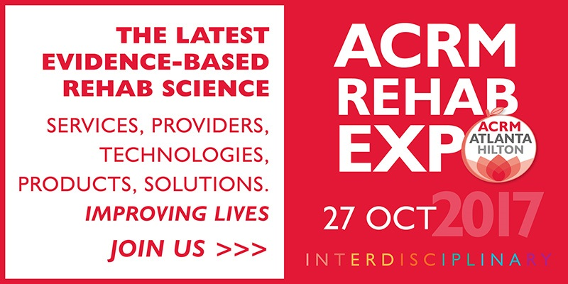
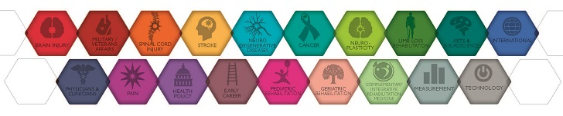
You’re Invited!
< YOUR COMPANY NAME > will be demonstrating the new < PRODUCT NAME > at the ACRM Annual Conference in Atlanta on 25 October and we’d love for you to join us FREE of CHARGE.
The international ACRM conference and EXPO, Progress in Rehabilitation Research (PIRR), is coming to Atlanta, 23 - 28 OCT. Bringing together rehabilitation researchers, physicians, clinicians, and consumers to learn about the latest advances in rehabilitation research, it's the LARGEST interdisciplinary conference in the world for rehabilitation research.
EXPO OPEN FREE TO THE PUBLIC
The ACRM Rehab EXPO is an exciting extension of the educational experience and the networking hub of the conference, showcasing providers of innovative rehabilitation technologies, products, and services.
We invite you to explore the EXPO free on FRI 27 OCT
9:30 AM - 2:15 PM (Registration required)
- Visit more than 100 exhibits – Leading suppliers of rehab products & services
- Product Theater – New product research & demonstrations from featured exhibitors
- Chat with the Experts – Small group discussion with experts on a variety of topics
- Launch Pad – Contestants pitch an original rehabilitation technology business or solution to a panel of rehab industry experts & an audience of EXPO visitors to win prizes
____________________________________________________________________________________
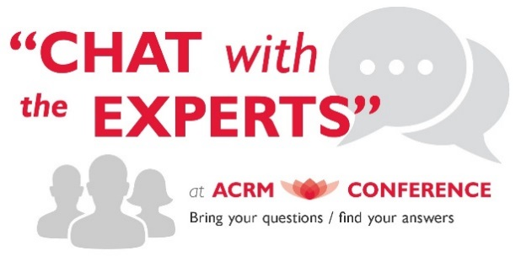

GET THE FACTS
Featuring nonstop EVIDENCE-BASED content for 18 focus areas, including brain injury, spinal cord injury, stroke, neurodegenerative diseases, cancer, pain, pediatric and geriatric rehabilitation and more, the ACRM Conference offers an outstanding range of topics and training for all members of the rehab team, including people with disabilities, their caregivers and family members.
FIRST-TIME ATTENDEES
Attend the 3.5-day CORE Conference (25 - 28 OCT) for as little as $699 / Consumer Member.
Nonmembers, use COUPON CODE: 2017Group-KOL for $100 OFF!
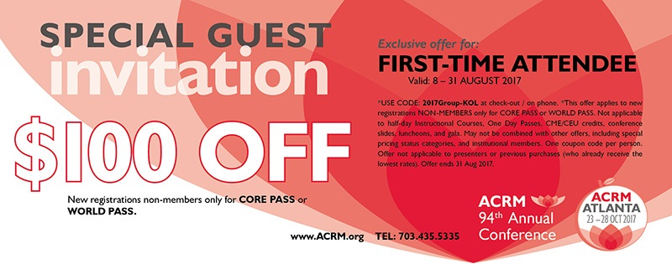
REGISTER NOW
OR USE REG FORM PDF
Use COUPON CODE: 2017Group-KOL
Need assistance? Contact memberservices@acrm.org or Call +1.703.435.5335

2017 ACRM Conference Exhibitors (as of 31 July)
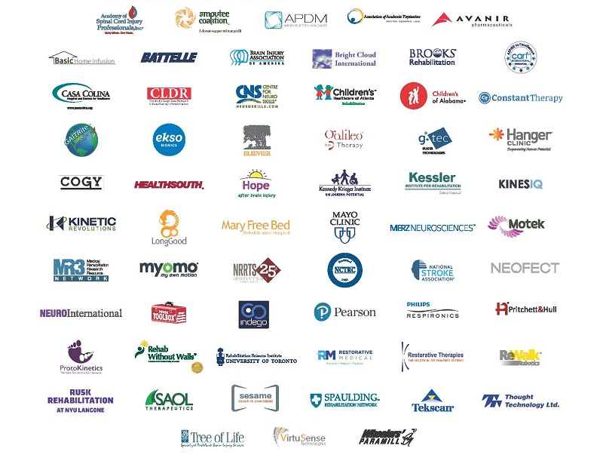

ACRM Conference: Progress in Rehabilitation Research (#PIRR2017)
CORE Conference 25 - 28 OCT 2017 // Pre-Conference 23 - 25 OCT 2017
REGISTER NOW // BOOK HOTEL // SEE PROGRAM

